Honor Statement: I certify that all the work on this test is my own. I have not cheated, nor have I acted dishonorably in any way concerning the information on this test.

Signature: ________________________________________ Date: ______________________

AP Physics 2 - 3-Weeks Test

- Rosalie is running to the southwest at 7 m/s. Sara is standing directly east of her, 10 m away, holding a nerf dart gun with a muzzle-velocity of 25 m/s. At what angle should Sara aim the dart gun to hit Rosalie?

- You are visiting the planet Mercury. You drop a ball from various heights in order to determine the acceleration due to gravity. You collect the following information:

  - Sketch a graph of the data:

  - What variable(s) should be manipulated in order to obtain a straight line? Calculate the values of this manipulated variable, and add them to the table.

  - Graph your data. Include appropriate units and labels.

  - Use the slope of this line to calculate acceleration due to gravity on Mercury.

- The vertical position of an elevator is shown by the graph below:
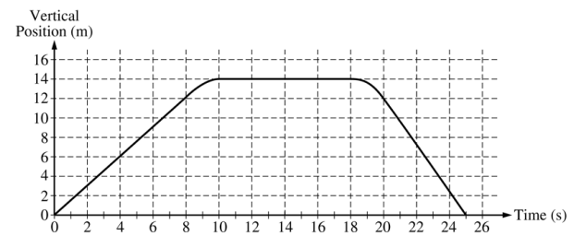
  - On the grid below, graph the velocity of the elevator as a function of time:
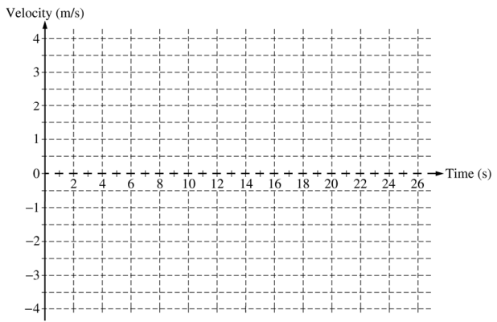
  - Calculate the average acceleration for the time period t = 8s to t = 10s

  - On the box below, draw an arrow to indicate the direction of this average acceleration.

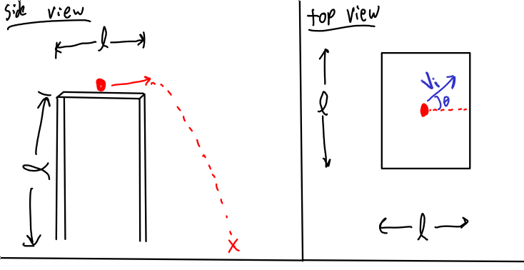
- A ball is placed in the center of a table, with length, width, and height of l. It is given an initial velocity of v_{i} at an angle θ north of east (where θ < 45°).
  - Derive an expression for the time it takes for the ball to reach the edge of the table.

  - Derive an expression for the length of time that the ball is falling.

  - How far from the center of the table does the ball land?

- Billy-Bob is fixing the roof of his house, that is angled at 25 degrees to horizontal. He slips, and begins to slide off the roof.
  - If Billy-Bob's s roof is frictionless, what is the acceleration due to gravity that Billy-Bob experiences pulling him down the ramp?

  - Billy-Bob slides along the roof for 3 meters. What is his velocity at the edge of the roof?

  - Billy-Bob then goes off the roof, following a ballistic trajectory. The building is 10 meters high. Where does Billy-bob land?

  - Assuming Billy-Bob can withstand an impact with a velocity of 8 m/s without getting seriously hurt, will he have to go to the hospital?

